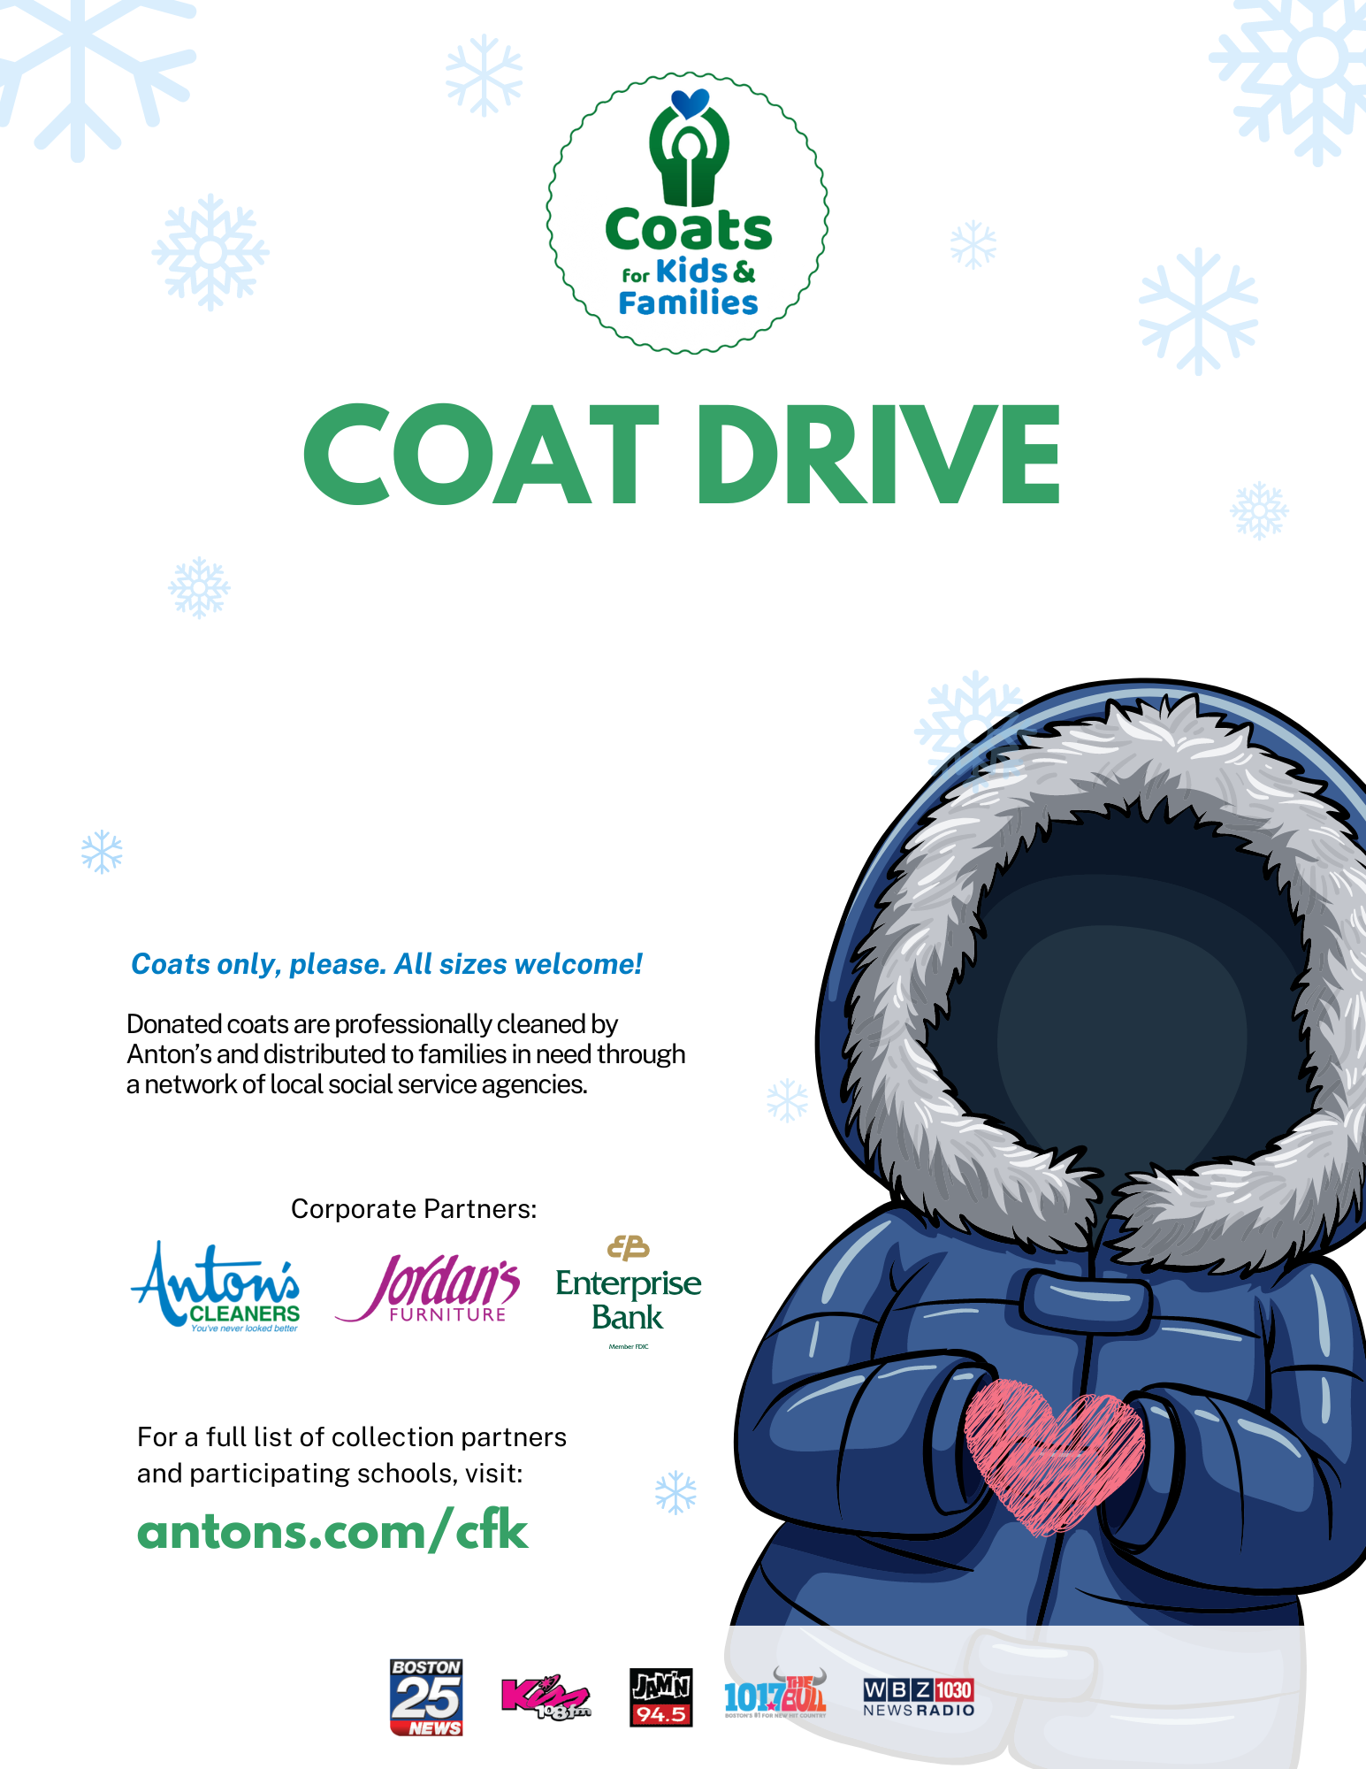

Donate warm winter coats for children and adults at [Company Name]!

[Optional logo]

[NOW-END DATE]