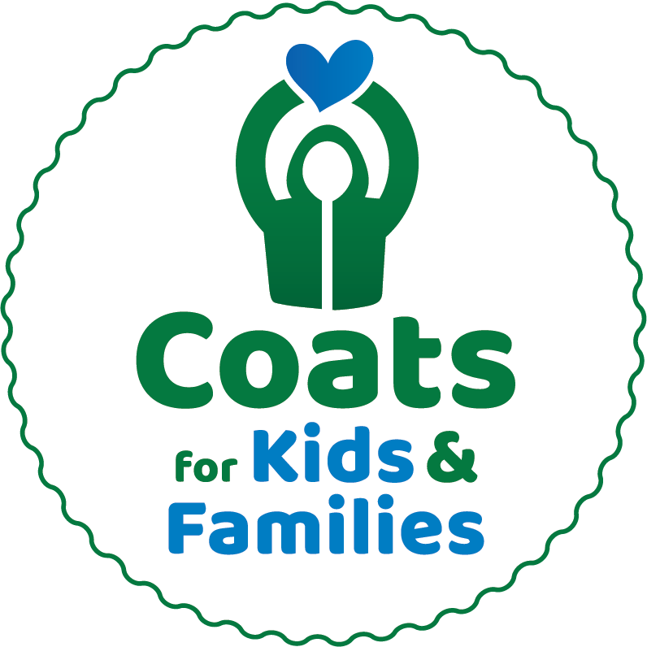

For Immediate Release
Public Contact: Stephanie Littlefield, Stephanie@antons.com or 978-851-3721 x15
Media Contact: Julie Dennehy, Dennehy PR, julie@dennehypr.com or 508-479-9848

<SCHOOL/COMPANY name> is teaming up with Caring Partners'
Coats for Kids & Families To Collect Winter Coats of All Sizes
For Those in Need Through January 8th

Winter coats needed to fulfill one mission:
“Anyone who needs a coat, will have one.”

<TOWN NAME, MA (Date)> – In tough economic times and cold New England weather, a warm coat isn’t a luxury… it is a necessity. In our very own community, there are thousands of children and adults who may otherwise not have access to warm winter coat this winter.

<School/Company Name> is proud to be a collection partner for Coats for Kids & Families. Coats collected at <school/company name> will be professionally cleaned by Anton’s and given to local nonprofits, social service agencies, and schools for distribution.

To donate coats for children and adults, <how, where, and when to donate coats>

The Coats for Kids & Families coat drive sponsored by Anton’s Cleaners, Enterprise Bank, and Jordan’s Furniture runs October 3 through January 8, 2022. With the help of local schools and community partners, the organization has collected, cleaned, and distributed 1,150,631 since the program began in 1995.

“For nearly three decades, Caring Partners has had one mission: anyone who needs a coat, will have one,” said Arthur Anton Jr., COO of Anton’s Cleaners and founder of the program. “Local schools, companies, clubs, and nonprofits collaborate each year to collect, clean and distribute 50,000 winter coats - it is nothing short of a miracle. We are proud this program gives back directly to the communities we serve.”

Coats for Kids & Families accepts warm winter coats that are gently used, good quality, and all sizes (especially XL and infant/pre-K sizes). The drive does not accept coats with rips, tears, broken zippers, or permanent stains, nor can we accept sweatshirts, vests and spring coats. Coats will also be collected at all Anton's Cleaners, Jordan's Furniture, and Enterprise Bank locations through January 8th.

Coats for Kids & Families is New England's largest coat drive, with more than 200 school groups making up over one half of all collections each year. Local public, parochial and independent schools experience the rewards of community service and get incentivized through the School Rewards Program™ offering a total of six $1000 prizes to schools. Prizes will be awarded to elementary, middle and high schools who collect the most coats total and the coats donated per student enrolled, thus leveling the playing field so everyone has a chance to win. See website for registration form and details: antons.com/cfk.

Partners for the 2022-2023 Coats for Kids & Families drive include Anton's Cleaners, Enterprise Bank, Jordan's Furniture, Boston 25, KISS 108, JAM’N 94.5, 101.7 The Bull, and WBZ News Radio.

For more information, visit contact Stephanie Littlefield, Anton’s Cleaners Community Relations, at 978-851-3721 x15 or Stephanie@antons.com.

To register your school or company online to participate or donate, or for more information, visit http://antons.com/cfk.
###

