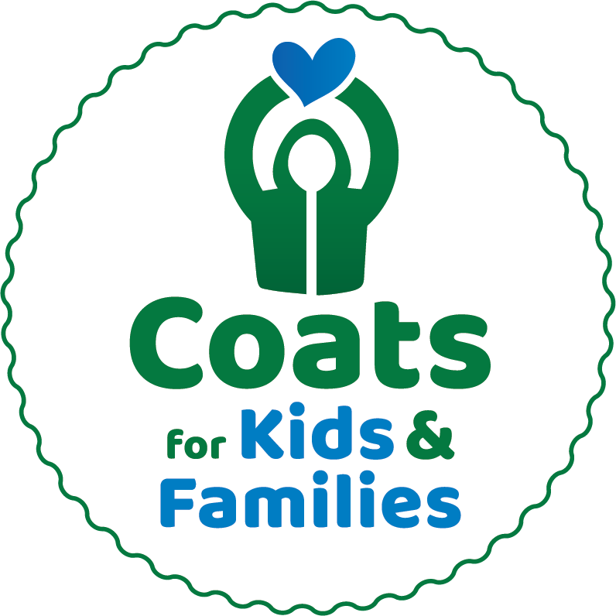

For Immediate Release
Public Contact: Stephanie Littlefield, Stephanie@antons.com or 978-851-3721 x15
Media Contact: Julie Dennehy, Dennehy PR, julie@dennehypr.com or 508-479-9848

<YOUR SCHOOL/COMPANY> is teaming up with Caring Partners'
Coats for Kids & Families To Collect Winter Coats of All Sizes
For Those in Need Through January 7th

Winter coats needed to fulfill one mission:
“Anyone who needs a coat, will have one.”

<TOWN NAME, MA (Date)> – In hard economic times and looming cooler weather, a warm coat isn’t a luxury… it is a necessity. In every community, there are thousands of children and adults who may otherwise not have access to warm winter coat this winter.

<School/Company Name> is proud to be a collection partner for Coats for Kids & Families. Coats collected at <school/company name> by <deadline> will be professionally cleaned by Anton’s and given to local nonprofits, social service agencies, and schools for distribution.

Sponsored by Anton’s Cleaners, Enterprise Bank, and Jordan’s Furniture, Coats for Kids & Families has collected, cleaned, and distributed 1,212,369 free coats at more than 70 collection locations and events since the program began in 1995.

Coats for Kids & Families accepts warm winter coats that are new or gently used, good quality, and all sizes (especially XL and infant/pre-K sizes). The drive does not accept coats with rips, tears, broken zippers, or permanent stains, nor does the drive accept sweatshirts, vests and spring coats, boots, scarves or gloves.

“For nearly three decades, Caring Partners has had one mission: anyone who needs a coat, will have one,” said Arthur Anton Jr., COO of Anton’s Cleaners and founder of the program. “Local schools, companies, clubs, and nonprofits collaborate each year to collect, clean and distribute 50,000 winter coats - a miraculous feat. This program gives back directly to the communities we serve, and we are proud to keep this program going as we approach three decades of service.”

According to Eliot Tatelman, President of Jordan’s Furniture, “We are happy to continue our long-running support of Coats for Kids & Families, helping to make sure that anyone who needs a warm, winter coat will have one. And funding the School Rewards Program is so important. It not only provides an extra incentive to the schools, but teaches students a meaningful lesson about helping the community around them.”

School groups and organizations are critical to the program’s success. Each year, more than 200 dedicated school groups are responsible for half of all coat collections. Local public, parochial and independent schools experience the rewards of community service and get incentivized through the School Rewards Program™ offering six $1000 prizes to schools who collect the most coats per capita – leveling the playing field so everyone has a chance to win. See website for registration form and details: antons.com/cfk.

Partners for this year’s Coats for Kids & Families drive include Anton's Cleaners, Enterprise Bank, Jordan's Furniture, Boston 25, KISS 108, JAM’N 94.5, 101.7 The Bull, 100.7 WZLX, WRKO, and WBZ News Radio.

For more information, visit contact Stephanie Littlefield, Anton’s Cleaners Community Relations, at 978-851-3721 x15 or Stephanie@antons.com. To register your school online to participate or donate, or for more information, visit http://antons.com/cfk.

###

