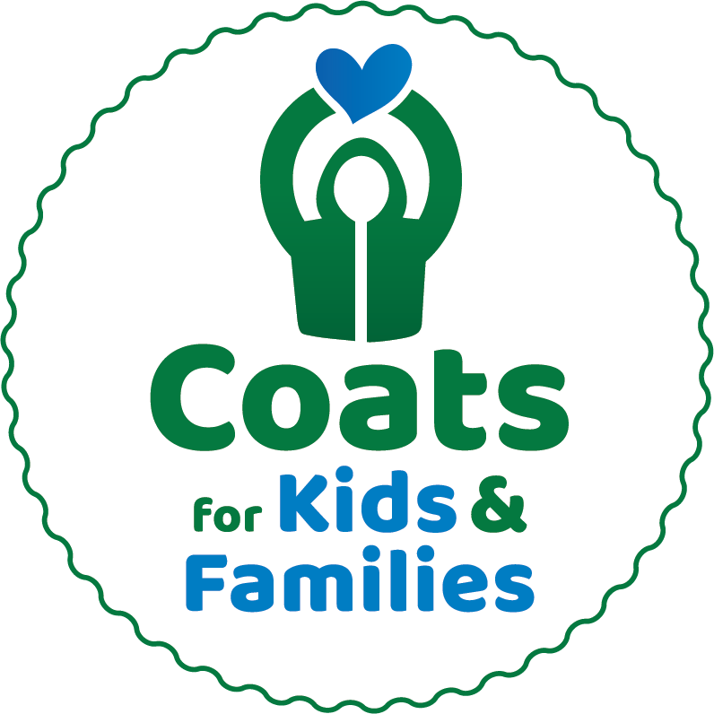

**For Immediate Release**

Public Contact: Stephanie Littlefield, [Stephanie@antons.com](mailto:Stephanie@antons.com) or 978-851-3721 x15

Media Contact: Julie Dennehy, Dennehy PR, [julie@dennehypr.com](mailto:julie@dennehypr.com) or 508-479-9848

**<YOUR SCHOOL/COMPANY> is teaming up with Caring Partners' Coats for Kids & Families To Collect Winter Coats of All Sizes For Those in Need Through January 10th, 2026**

***Winter coats needed to fulfill one mission:***

***“Anyone who needs a coat, will have one.”***

<TOWN NAME, MA (Date)> – As the price of everyday items like groceries and gasoline continue to rise and temperatures start to drop, families struggling with expenses may find that a warm winter coat is a necessity that isn’t in the budget. This year, thousands of children and adults may otherwise not have access to warm winter coats this winter.

As New England’s largest coat drive for nearly 30 years, Caring Partners’ Coats for Kids and Families collects gently used coats of all sizes and for all ages from **October 14th, 2025 through January 10th, 2026**.

<School/Company Name> is proud to be a collection partner for Coats for Kids & Families. Coats collected at <school/company name> by <deadline> will be professionally cleaned by Anton’s and given to local nonprofits, social service agencies, and schools for distribution right in our area.

Sponsored by **Anton’s Cleaners, Jordan’s Furniture, and Rockland Trust**, Coats for Kids & Families has collected, cleaned, and distributed 1,810,839 free coats at more than 70 collection locations and events since the program began in 1995.

Coats for Kids & Families accepts warm winter coats that are new or gently used, good quality, and **all sizes** (especially XL and infant/pre-K sizes). The drive does not accept coats with rips, tears, broken zippers, or permanent stains, nor does the drive accept sweatshirts, vests and spring coats, boots, scarves or gloves.

“Today more than ever, we are proud to spend three decades giving back directly to the community through Caring Partners. For 30 years, we have never wavered from our mission: anyone who needs a coat will have one,” said **Arthur Anton Jr.,** COO of Anton’s Cleaners and founder of the program. “Companies, schools, nonprofits, and clubs work hard every year to help us collect, clean, and distribute 50,000 winter coats to anyone who needs one.”

**School groups and organizations are critical to the program’s success.** Each year, more than 200 dedicated school groups are responsible for half of all coat collections. Local public, parochial and independent schools experience the rewards of community service and get incentivized through the [School Rewards Program](http://antons.com/cfk/school/school-rewards/)™ offering six generous prizes to top-placing schools who collect the most coats – leveling the playing field so everyone has a chance to win. See website for registration form and details: [antons.com/cfk](https://antons.com/cfk/get-involved/register-your-school/).

Partners for this year’s Coats for Kids & Families drive include Anton's Cleaners, Jordan's Furniture, Rockland Trust, and Boston 25.

For more information, visit contact Stephanie Littlefield, Anton’s Cleaners Community Relations, at 978-851-3721 x15 or [Stephanie@antons.com](mailto:Stephanie@antons.com). To register your organization online to participate or donate, or for more information, visit <http://antons.com/cfk>.

###