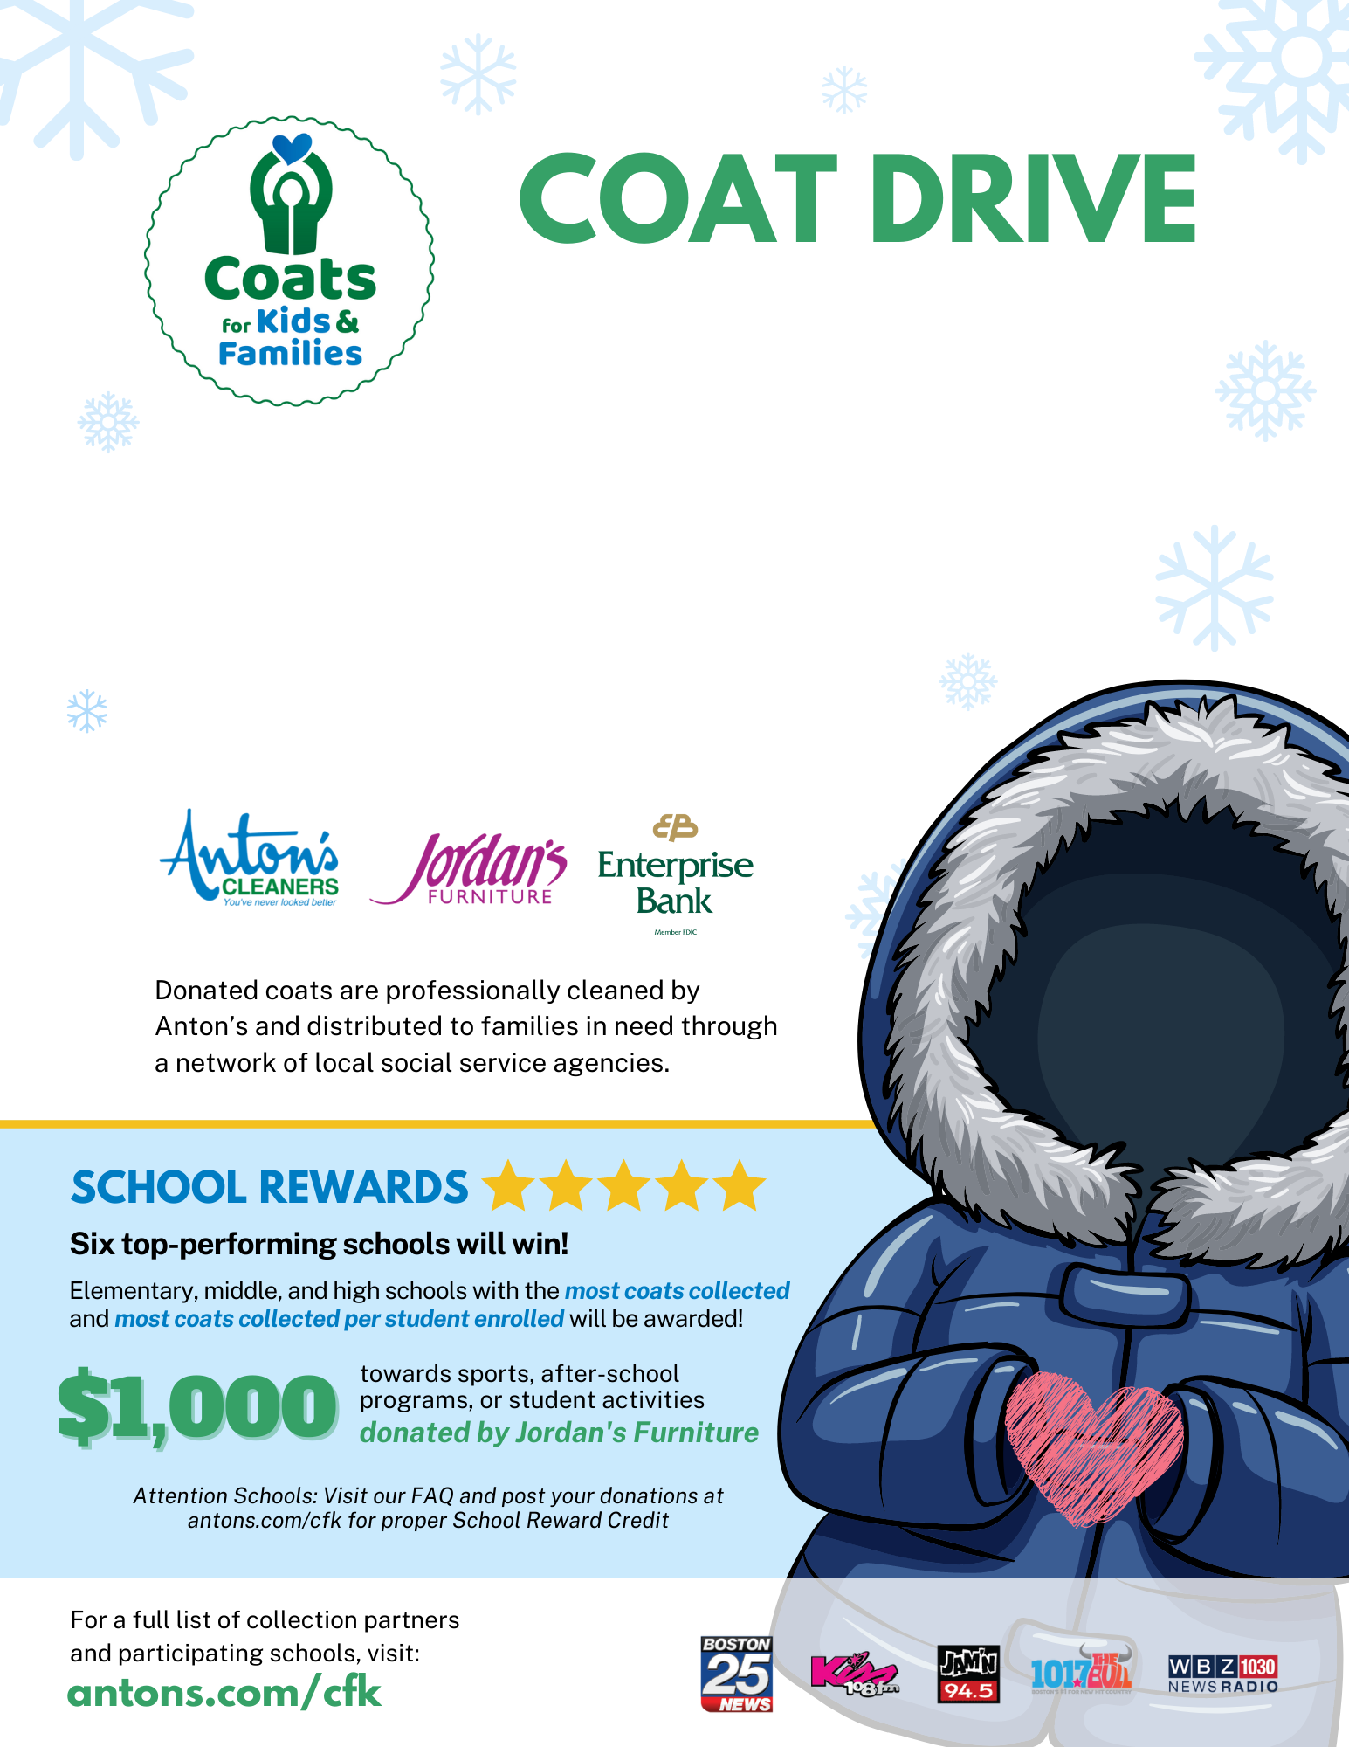

[NOW-END DATE]

**Donate warm winter coats for children and adults [school-specific info - i.e. in the lobby].**

***All sizes welcome! Coats only, please.***

[School Name] is a registered collection partner for Coats for Kids & Families!