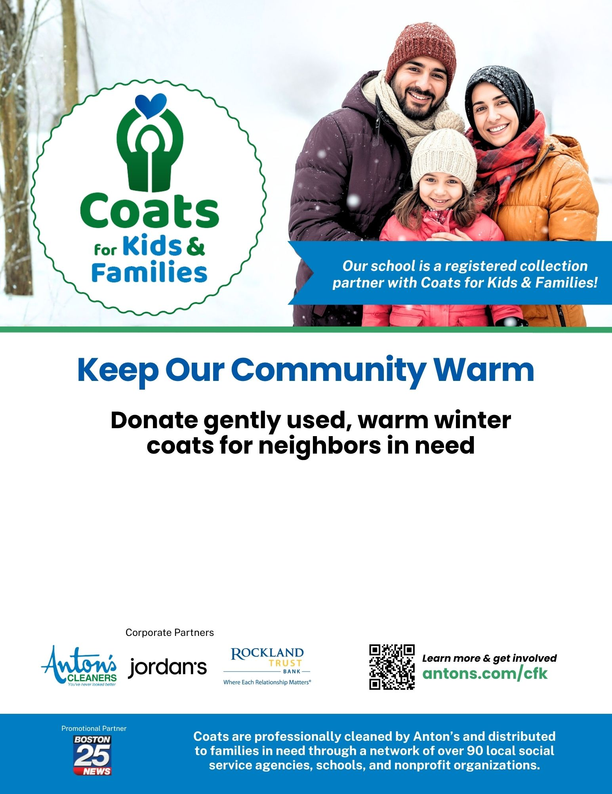
[NOW-END DATE]
Winter coats for children and adults are needed! Bring them to [school-specific info - i.e. in the lobby].

